Lesson 14: Right-Triangle Trigonometry
Math 2412 Precalculus · Unit 3: Trigonometric Functions & Triangles · Student Guided Notes
Name: ______________________________ Date: ______________

Lesson objective
Students will find the six trigonometric ratios of an acute angle in a right triangle, find exact values for 30°, 45°, and 60°, use cofunction identities, and solve right triangles in applications with angles of elevation and depression.

Before class
Complete these short tasks before the lesson. They review skills this lesson builds on.
- A right triangle has legs 5 and 12. Find the hypotenuse (Pythagorean theorem).
- Rationalize $1/\sqrt{3}$ and $2/\sqrt{2}$ (Lesson 1).
- Convert $π/3$ and $5π/12$ to degrees (Lesson 13).

Skill 14.1: The Six Trigonometric Ratios

Key ideas
For an acute angle θ in a right triangle, name the sides from the point of view of θ: the side across from θ is ______________ (1), the side next to θ (not the hypotenuse) is ______________ (2), and the side across from the right angle is the ______________ (3).
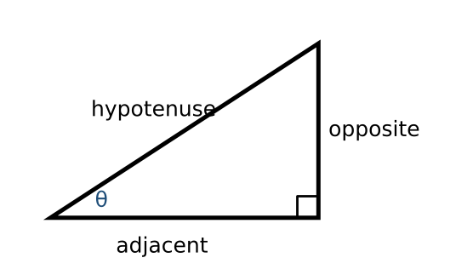
Sine | Cosine | Tangent
$sin θ$ = ________ (4) | $cos θ$ = ________ (5) | $tan θ$ = ________ (6)
Cosecant: $csc θ=\frac{1}{sin θ}$ = ________ (7) | Secant: $sec θ=\frac{1}{cos θ}$ = ________ (8) | Cotangent: $cot θ=\frac{1}{tan θ}$ = ________ (9)

Memory aid: SOH-CAH-TOA. Each reciprocal ratio is the first ratio flipped upside down.

Example 1: sine, cosine, and tangent
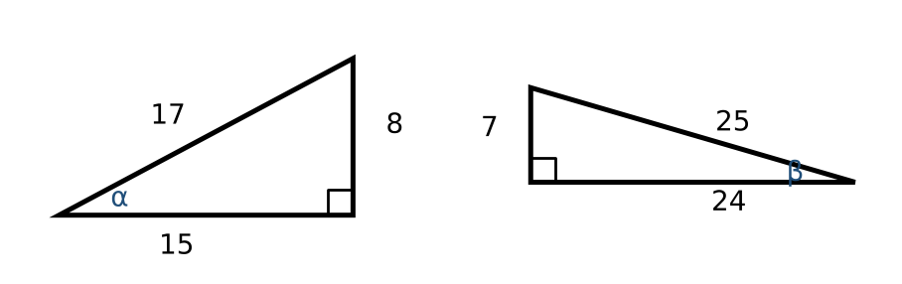
- Left: $sin α=\frac{8}{17}$, $cos α=\frac{15}{17}$, $tan α=\frac{8}{15}$.
- Right: $sin β=\frac{7}{25}$, $cos β=\frac{24}{25}$, $tan β=\frac{7}{24}$.

Example 2: all six ratios
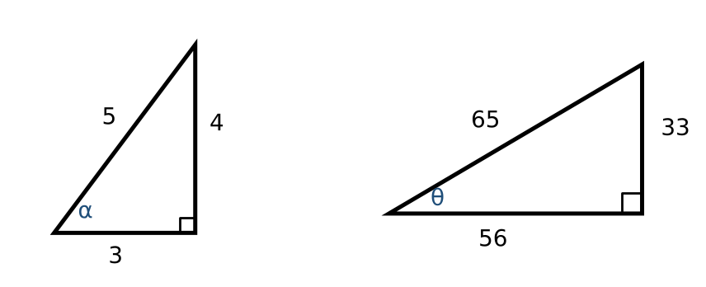
Angle | sin | cos | tan | csc | sec | cot
α | $\frac{4}{5}$ | $\frac{3}{5}$ | $\frac{4}{3}$ | ________ (10) | ________ (11) | ________ (12)
θ | $\frac{33}{65}$ | $\frac{56}{65}$ | $\frac{33}{56}$ | ________ (13) | ________ (14) | ________ (15)

Practice
a. A right triangle has legs 5 and 12. Let θ be the angle opposite the side 5. Find all six trig ratios of θ. | b. θ is acute and $sin θ=\frac{3}{7}$. Draw a triangle and find $cos θ$ and $tan θ$.

Skill 14.2: Special Right Triangles

Key ideas
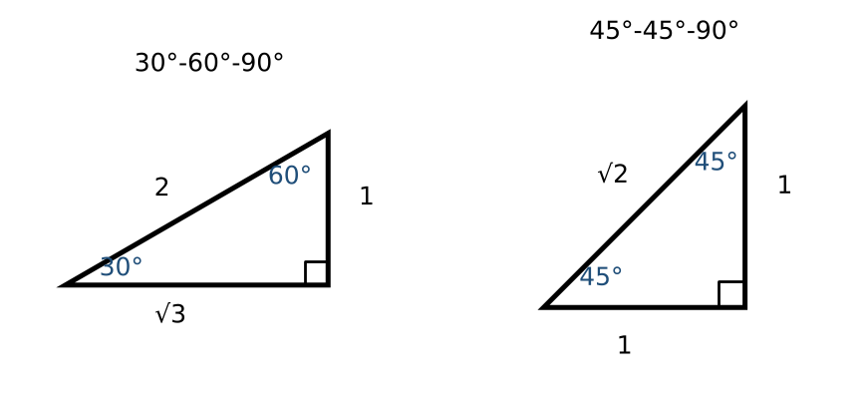
- In a 30°-60°-90° triangle the sides are $1:\sqrt{3}:2$. The short leg is opposite ______________ (16).
- In a 45°-45°-90° triangle the sides are $1:1:\sqrt{2}$.
θ | sin θ | cos θ | tan θ
30° = $π/6$ | $\frac{1}{2}$ | ________ (17) | ________ (18)
45° = $π/4$ | ________ (19) | ________ (20) | ________ (21)
60° = $π/3$ | ________ (22) | $\frac{1}{2}$ | ________ (23)

Example: all six values for $π/3$ and $π/4$
- $π/3=60°$: $sin =\sqrt{3}/2$, $cos =\frac{1}{2}$, $tan =\sqrt{3}$, $csc =2/\sqrt{3}=2\sqrt{3}/3$, $sec =2$, $cot =1/\sqrt{3}=\sqrt{3}/3$.
- $π/4=45°$: $sin =cos =\sqrt{2}/2$, $tan =1$, $csc =sec =\sqrt{2}$, $cot =1$.

Practice
a. Find the exact values of $sec 45°$ and $cot 30°$. | b. Evaluate $2sin 60°−tan 45°$ exactly. | c. Evaluate $\sin^{2}(π/6)+\cos^{2}(π/6)$.

Skill 14.3: Cofunction Identities

Key ideas
The two acute angles of a right triangle are ______________ (24): they add to 90° (or $π/2$). The side opposite one angle is adjacent to the other, so each function of an angle equals its cofunction of the complement.
Sine and cosine | Tangent and cotangent | Secant and cosecant
$sin θ=cos(π/2−θ)$ | $tan θ$ = ________ (25) | $sec θ$ = ________ (26)
$cos θ$ = ________ (27) | $cot θ$ = ________ (28) | $csc θ=sec(π/2−θ)$

Example
- If $sin t=\frac{5}{12}$, then $cos(π/2−t)=sin t=\frac{5}{12}$.
- If $csc(π/6)=2$, then $sec(π/3)=2$, because $π/3=π/2−π/6$.

Practice
a. If $cos t=0.3$, find $sin(π/2−t)$. | b. Find the acute angle θ with $tan 20°=cot θ$.

Skill 14.4: Solving Right Triangles

Key ideas
- Draw the triangle and label the known sides and angles.
- Pick a ratio that uses the known side and the side you want.
- Solve the equation for the unknown side. Use the fact that the acute angles add to 90° for the other angle.
- Check the answer: the hypotenuse must be the longest side.
- The angle of elevation is measured ______________ (29) from the horizontal to the line of sight; the angle of depression is measured ______________ (30) from the horizontal.
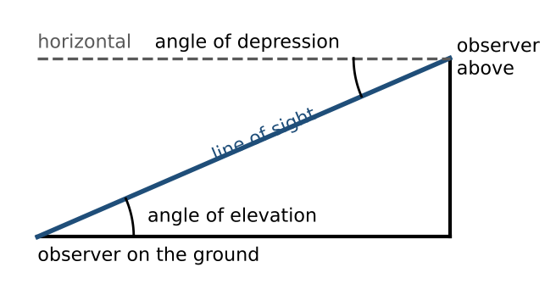

Example 1: solve the triangle
A right triangle has one angle of $π/3$ and hypotenuse 20. Find the unknown sides and angle.
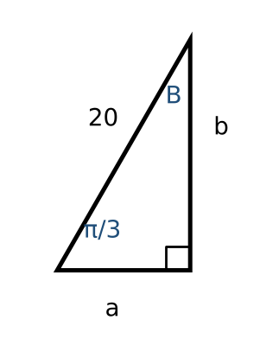
- $cos(π/3)=\frac{a}{20}$, so $a=20·\frac{1}{2}=10$.
- $sin(π/3)=\frac{b}{20}$, so $b=20·\sqrt{3}/2=10\sqrt{3}≈17.32$.
- $B=π/2−π/3=π/6$.

Example 2: height of a tree
A person stands 30 feet from a tree, and the angle of elevation to the top is 57°. $tan 57°=\frac{h}{30}$, so $h=30tan 57°≈46.20$ feet.

Example 3: a building and a flagpole
From 500 feet away, the angle of elevation to the top of a building is 24°, and to the top of a flagpole on the building is 27°.
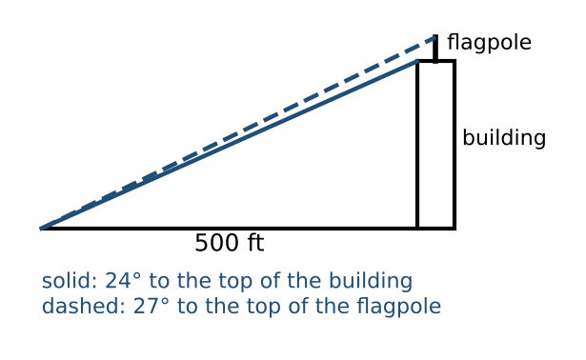
- Building: $500tan 24°≈222.61$ feet. Top of the pole: $500tan 27°≈254.76$ feet.
- Flagpole: $254.76−222.61≈32.15$ feet.

Practice
a. A ladder rests against a building at an angle of $5π/12$ with the ground and reaches a windowsill 50 feet up. How long is the ladder, to the nearest foot? | b. Solve the right triangle with leg 12 opposite angle $A=35°$. | c. From a cliff 120 m high, the angle of depression to a boat is 18°. How far is the boat from the base of the cliff?

Exit check
1. In a right triangle, θ has opposite side 9 and hypotenuse 41. Find $cos θ$ and $tan θ$.

2. Find the exact value of $sin 60°+cos 30°$.

3. A ramp rises 3 feet at an angle of 5°. How long is the ramp?

